Sexual Harassment and how bystanders or victims, could predict or stop it.

# Postnote

# Postnote

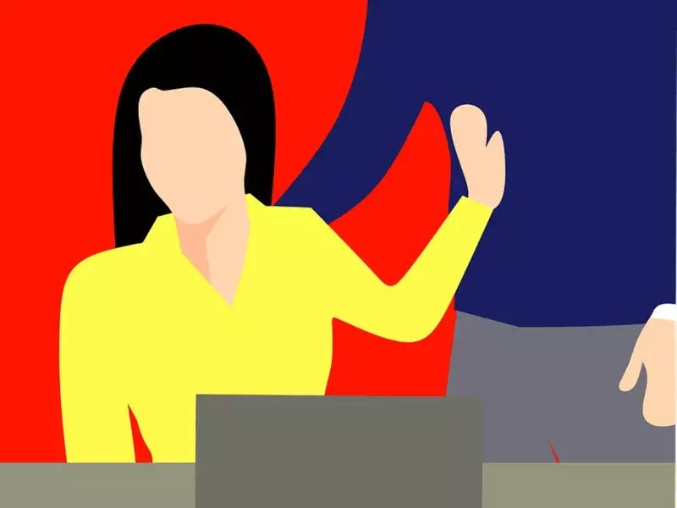

Background

The sexual harassment definition of the Cambridge Dictionary is unwanted or offensive sexual attention, suggestions, or talk, from an employer or other person possibly in a higher position(sexual harassment, 2021). The problem has arisen in the United Kingdom. A study by the Guardian(Four-fifths of young women in the UK have been sexually harassed, survey finds, 2021)

found out 86% of women aged between 18-24 years old have been sexually harassed in public, private spaces, and even by employee colleagues. From the remaining 14%, 11% preferred not to answer, and only 3% mentioned that they never been part of sexual harassment.

The victim as well as the harasser could be a woman or a man, as well the victim does not have to be of opposite sex.

Sexual harassment can have serious consequences on women emotional status but not only, even in the career status. There are cases of women being sexual harassed by employee with higher status than them.

Studies show even if cases are arising, women prefer not to report them, and this will be explained below.

There are multiple types of sexual harassment :

* Verbal Harassment :

This consists of verbal sexual offences as offensive suggestions, sexual comments about a person body or clothes, asking or talking about sexual fantasies, asking inappropriate personal questions about someones sexual life, whistling at someone or cat calls, referring to an adult as “babe” “honey” ”doll”, when the victim is unwelcome of them.

* Written Harassment :

With now social media arising written harassment is even popular. This consists of sending inappropriate sexual texts or e-mails. An example could be comments on social media about persons body, or it could be asking for an inappropriate picture.

* Visual Harassment :

This consists of displaying or sending sexually suggestive pictures or videos.

* Physical Harassment :

There are multiple examples of this. Physical harassment consists of inappropriate gestures, or touching, kissing, hugging without the consent of the victim.

### What women say about:

* “We are looking at a situation where younger women are constantly modifying their behaviour in an attempt to avoid being objectified or attacked, and older women are reporting serious concerns about personal safety if they ever leave the house in the dark – even during the daytime in winter.”(Claire Bennet executive director of UN women )
* “This is human right crisis. It s not just enough for us to keep saying “this is too difficult a problem for us to solve” it needs addressing now”(Claire Bennet executive director of UN women )
* “If you talk about wolf whistling or street harassment in the UK, you are liable to find yourself on the front page of a tabloid being called a “feminazi” and accused of overreacting, so of course young women don’t think they be taken seriously if they come forward”

What are the causes?

### Pornography effects:

* One cause which keeps reinforcing sexual dominance, objectification of women’s body, and promoting sexual abusive behaviour throughout teenagers is pornography.
* Not only promotes sexual abusive behaviour, but watching porn changes the perception of how the sexual act should occur. A study (Bridges et al, 2010) showed that pornography changes neural path and network in correlation to perception and behaviour towards women, and sexuality.

Sexual harassment have many causes. In this section causes are gonna be explained via different theories.

From a biologic point of view males tend to have stronger sexual drives, and this could result in an imbalance especially at work places. From the male point of view this is viewed as showing sexual interest in women, the problem arises when the victim in uninterested and sees the act as sexual harassment. Frustration can arise, as the victim refuses the sexual interest, and this could be also one of the main cases.

The causes are different considering from a cultural point of view. Sexual harassment in one of the main consequences of the stereotypes of gender roles that are in some cultures. This vary from male dominance, considering women just as bodies

(Cleveland and McNamara, n.d.). The sexual dominance, the desire to conquest more, the false stereotype of males being superior to women, these are ones of the strong predictors that could result in Sexual Harassment.

If the group of the perpetuator supports this values and beliefs, the perpetuator could have even stronger sexual harassment tendencies(Szymanski and Mikorski, 2017).

As well in some groups masculinity is valued throughout gestures perceived as sexual harassment.

One of the causes of the beliefs of power of men over women, could come from history when man had more privileges than women.

Sexual interactions in some cultures are perceived as an act of vengeance of the man, or punishment, instead of love. There could be a correlation between the frustration that is produced by the refusal, and seeing the sexual act as one of vengeance.

There is another theory sustaining that people with low sociocultural status as minorities or low class workers are more prone to sexual harassment by higher status people (ROSPENDA, RICHMAN and NAWYN, 2021). This theory relates more to boys/mans because in organisational-groups mans are more likely to be in higher status positions. One of the points of this theory is that man being in high social positions tend to be excused or not punished by legal activities because of their status. And this could also explain the continuity of the sexual harassment cases, and why women tend to report them in lower percentage each year.

As well, not only high status social people tend to Sexual Harass, but also statuses as client or customer. For example maids,

restaurant workers, migrant hotel workers showed high sexual harassment cases

There are cases in which the perpetuator could give rewards in case of sexual harassment, and this cases are most popular throughout organisational-groups. A high status perpetuator could afford to give the victim a reward or a higher social position status as an exchange for sexual gestures.

Even in the field of restaurant or hotels, there exist rewards as tips, that could be give as exchange for sexual inappropriate gestures.

Overview of the problem

There is a serious problem, because women tend to not say anymore anything about their sexual harassment(Four-fifths of young women in the UK have been sexually harassed, survey finds, 2021). This could be a serious problem, because women not saying anymore their cases could mean two things, that there exist a social idea that nothing is gonna happen and people are not gonna be punished, but also this could interfere with the law not being anymore a statistical rising problem.

A study by the YouGov(Four-fifths of young women in the UK have been sexually harassed, survey finds, 2021) of 1000 women showed that 96% percent of women do not report their cases anymore. More specifically, the idea that nothing is gonna be done in regard to the problem has been showed by 45% percent of women from the study. There could exist a correlation between the fact that 45% of women think that nothing is gonna be done regarding sexual harassment, and the theory mentioned above that usually perpetuators with high social status level are not being punished, and this could help propose a different point of view in finding solutions to solve the problem, and finding where most sexual offences happen.

Another study by the Everyday Sexism Project(Sexual Harassment in the Workplace is Found to Affect Over Half of UK Women, 2021))showed that on a survey of 1500 women, more than half reported to have been sexual harassed at work. This could be a serious issue

affecting meritocracy in social organisations, but also could be a challenge in people career.

Supposing from the first theory that perpetuators are people with higher social status, it is possible to assume that, selection of rewards, or statuses inside the organisation, or rewards are partially selected by them. A study conducted by Young Women(Quarter of young women fear they would lose their job if they reported sexual harassment, 2021) showed that over 17 per cent of women would be worried that they would be offered less overtime hours to work. This could raise a serious problem in someones career, and could have repercussions in someone even personal mental life, because of not achieving a career goal based only by refusing sexual gestures. The study also showed that 34% of women reported sexual harassment even when looking for work, and work interviews. The sexual harassment discrimination on job interviews could be also a way to improve the cases of sexual harassment, and they are gonna be presented on the prevention section. A report by “Its still a rich mans world”(Young Women’s Trust Annual Survey 2018: It’s (Still) a Rich Man’s World, 2021) showed that 31% of women didn’t even know how to report any sexual harassment cases. Concluding, based on the overview of the problem, it is possible to deduce and create some solutions that will target more specifically the problem.

Bystanders usual reaction

With the current levels of sexual offences arising, bystanders could play an important role in stopping the sexual offences. Bystanders could heard or see sexual harassments, in many ways. They could be part of a bigger social group, where males could talk between them about their values, and about their sexual personal life, but not only. Many cases of sexual harassment, happen in public spaces, at work, restaurants or bars, gyms, social groups. In each of these there could exist the possibility that there may exist a witness to the act. Starting from this presumption, it is possible to say that strategies for improving bystanders reaction could lower the sexual harassment cases.

One of the theories which mention the bystander effect support that witness fail to intervene because they think another person would do it, instead of them. Until a witness consider to intervene or not there are other steps that he takes in calculation. Firstly the witness has to interpret the sexual offence as a

problem, and this could raise some issues depending on the social values of the witness group. An example could be of a witness being part of a group where sexual dominance is approved and refusal is seen more as a “hard to get” person. After intercepting the act as a problem, the witness should feel responsible for start doing something and the last one would be to have the necessary skills to do something.

Victims consequences

Sexual harassment can lead to serious psychological problems as sleep disturbance, stress disorder, anxiety, low self-esteem, depression. As well also in their personal life refusal of sexual acts could lead to exclusion from certain groups, or obstacles in career as mentioned above, where women position arrive to be based on the sexual favours they do. The objectification of women’s body could lead to low self-esteem, to depression, and also to a distorted idea of their own body. Knowing that women tend to report lower and lower cases this could mean that another consequence could be hopelessness.

Strategies that could be implemented

In this section are gonna be explained different strategies that could be implemented to prevent sexual harassment cases. The strategies are gonna be explained in relation with the causes and the places where sexual harassment are taken place. In the causes section it is briefly explained that one of the popular sexual harassment places are in social organisational groups where social status level differ. Here one strategy that could be implemented would be to have a sexual offence offices where people could report what happened. In this case, for not existing conflicts of gender, women would audit women, and men would audit men. A case report would be 100% anonymous and confidential, so it could not put in any threat the victim. In these groups where offices are gonna be implemented, it should exist an education on how women should report their cases, so all steps could be easy understood, and there will be no more people who will not know how to report them.

As well, interviews would be taken by same gender interviewer, this could help decrease the cases of sexual harassment when looking for jobs. For restaurants and bars, what would stop the increase of numbers would be a ban for the certain customer, or an automatic method of being fined by police, for any sexual offence done.

In all cases sexual harassment could be decreased with the help of bystanders. An educational programme related to bystanders would help decrease the cases, not only in their work place but even outside of it. The main points in order to help bystanders prevent sexual offences would be to make them understand what are the places popular of sexual harassment and why it takes place.

This would mean that certain places to be informed with different posters, for bystanders to react immediately to any kind of offence.

As well they should be informed with mechanisms to recognise a sexual offence, or leading behaviours to it, as example: seeing a woman in a bar between many drunk man which are trying to approach her, or in a company seeing employee receiving refusal from the victim. In order for the act to not escalade, and if not possible to prevent it, it should be stopped at the first major signs which describe it a sexual offence. This could help stop earlier the act, and not leading to a different sexual abusive behaviour. Bystander would be also informed with different mechanisms or skills on how to stop it, when they recognise it, as calling immediately support, or helping the victim to escape and giving the steps to report the case.

As well, an implementation would be for

References :

* Bridges, A., Wosnitzer, R., Scharrer, E., Sun, C. and Liberman, R., 2010. Aggression and Sexual Behavior in Best-Selling Pornography Videos: A Content Analysis Update. *Violence Against Women*, 16(10), pp.1065-1085.
* Cleveland, J. and McNamara, K., n.d. Understanding Sexual Harassment: Contributions from Research on Domestic Violence and Organizational Change. *Sexual Harassment in the Workplace: Perspectives, Frontiers, and Response Strategies*, pp.217-240.
* the Guardian. 2021. *Four-fifths of young women in the UK have been sexually harassed, survey finds*. [online] Available at: <https://www.theguardian.com/world/2021/mar/10/almost-all-young-women-in-the-uk-have-been-sexually-harassed-survey-finds> [Accessed 7 November 2021].
* Focus for Health. 2021. *How Pornography Impacts Violence Against Women and Child Sex Abuse - Focus for Health*. [online] Available at: <https://www.focusforhealth.org/how-pornography-impacts-violence-against-women-and-child-sex-abuse/> [Accessed 7 November 2021].
* People Management. 2021. *Quarter of young women fear they would lose their job if they reported sexual harassment*. [online] Available at: <https://www.peoplemanagement.co.uk/news/articles/quarter-young-women-fear-lose-job-reported-sexual-harassment#gref> [Accessed 7 November 2021].
* ROSPENDA, K., RICHMAN, J. and NAWYN, S., 2021. *DOING POWER*.
* Dictionary.cambridge.org. 2021. *sexual harassment*. [online] Available at: <https://dictionary.cambridge.org/dictionary/english/sexual-harassment> [Accessed 7 November 2021].
* Safeline - Believe in you - Surviving sexual abuse & rape. 2021. *Sexual Harassment in the Workplace is Found to Affect Over Half of UK Women*. [online] Available at: <https://www.safeline.org.uk/sexual-harassment-in-the-workplace-is-found-to-affect-over-half-of-uk-women/> [Accessed 7 November 2021].
* Szymanski, D. and Mikorski, R., 2017. Sexually Objectifying Environments. *Psychology of Women Quarterly*, 41(3), pp.314-324.
* Equally Ours. 2021. *Young Women’s Trust Annual Survey 2018: It’s (Still) a Rich Man’s World*. [online] Available at: <https://www.equallyours.org.uk/young-womens-trust-annual-survey-2018-its-still-a-rich-mans-world/> [Accessed 7 November 2021].